PROJECT DESIGN PHASE - II

|  |  |
| --- | --- |
| Date | 10 October 2022 |
| Team ID | PNT2022TMID45281 |
| Project Name | A Novel Method for Handwritten Digit  Recognition System |
| Maximum Marks | 4 Marks |

DATA FLOW DIAGRAM

A Data Flow Diagram (DFD) is a traditional visual representation of the information flows within a system. A neat and clear DFD can depict the right amount of the system requirement graphically. It shows how data enters and leaves the system, what changes the information, and where data is stored.

# DFD Level-0

The DFD Level-0 consists of two external entities, the UI and the Output, along with a process, representing the CNN for Digit Recognition .Output is obtained after processing.

USER

OUTPUT

CNN FOR DIGITAL PROCESSING

PROCESSING

IMAGE

# DFD Level-1

The DFD Level-1 consists of 2 external entities, the GUI and the Output, along with five process blocks and 2 data stores MNIST data and the Input image store, representing the internal workings of the CNN for Digit Recognition System. Process block imports MNIST data from library. Process block imports the image and process it and sends it to block where regression model is built. It sends objects with probabilities to CNN where weights are updated and multiple layers are built. Block trains and evaluates the model to generate output.

|  |  |  |
| --- | --- | --- |
| PRE | BUILD | CONVOLU |
| PROCESSI | REGRESS | TION |
| NG | ION | NERUAL |
|  | MODEL | NETWORK |

# DFD Level-2

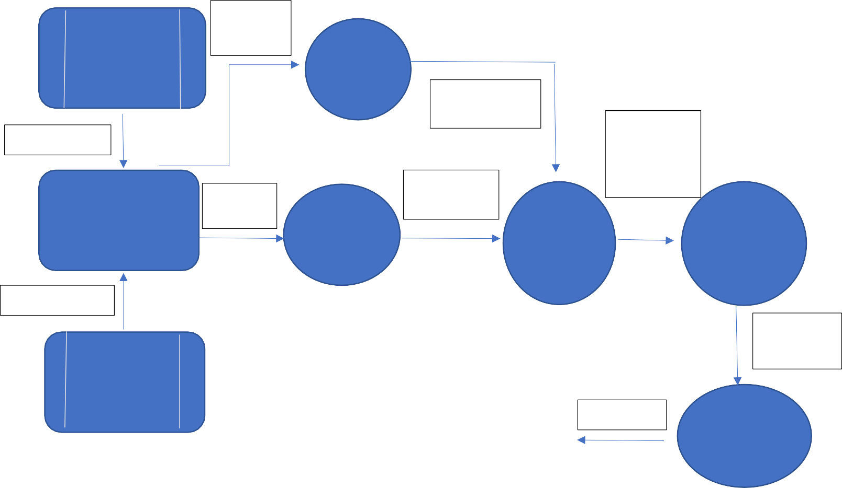

MNIST

DATA

MNIST DATA

IMPORT

DATA SET

MNSIT DATA

SET

MNIST DATA

USER INTERFACE

USER

IMAGE

PROCESSED

IMAGE

DATA SET

OBJECT WITH POBABILITY

USER INPUT

INPUT IMAGE

UPDATED

WEIGHT

STORE

RESULT

RESULT

TRAIN AND

EVALUATE MODEL

The DFD Level-2 for import data(figure 4) consists of two external data and one entity UI along with three process blocks, representing the three functionalities of the CNN for Digit Recognition System. It imports data from MNIST data store and stores on the system.

MNIST DATA

USER INTEFACE

MNIST DATA

MNIST DATA

IMPORT

DATA

STORE

DATA SET

MNIST DATA SET

STORE

MNIST DATA

IMPORTED MNIST

**USER STORIES**

|  |  |  |  |  |  |  |
| --- | --- | --- | --- | --- | --- | --- |
| **User Type** | **Functional Requirement (Epic)** | **User Story Number** | **User Story / Task** | **Acceptance criteria** | **Priority** | **Release** |
| Customer (Mobile user) | Registration | USN-1 | As a user, I can register for the application by entering my email, password, and confirming my password. | I can access my account / dashboard | High | Sprint-1 |
|  |  | USN-2 | As a user, I will receive confirmation email once I have registered for the application | I can receive confirmation email & click confirm | High | Sprint-2 |
|  |  | USN-3 | As a user, I can register for the application through gmail or facebook | I can register & access the dashboard with Facebook Login | Medium | Sprint-2 |
|  | Login | USN-4 | As a user, I can log into the application by entering email & password | I can login to the application | High | Sprint-1 |
|  | Dashboard | USN-5 | Go to dashboard and refer the content about our project | I can read instructions also and the home page is  user-friendly. | Low | Sprint-1 |
|  | Upload Image | USN-6 | As a user, I can able to input the images of digital documents to the application | As a user, I can able to input the images of digital documents to the application | High | Sprint-3 |
|  | Predict | USN-7 | As a user I can able to get the recognised digit as output from the images of digital documents or images | I can access the recognized digits from digital document or images | High | Sprint-3 |
|  |  | USN-8 | As a user, I will train and test the input to get the maximum accuracy of output. | I can able to train and test the application until it gets maximum accuracy of the result. | Medium | Sprint-4 |
| Customer (Web user) | Login | USN-9 | As a user, I can use the application by entering my email, password. | I can access my account | Medium | Sprint-4 |
| Customer Care Executive | Dashboard | USN-10 | upload the image | Recognize and get the output | High | Sprint-1 |
| Administrator | Security | USN-11 | updated the features | checking the security | Medium | Sprint-1 |